MCTS and Coevolution in Catan

Jack Harmeling and William Bartlik
harmeling.j@husky.neu.edu bartlik.w@northeastern.edu

Abstract
The purpose of this project was to build AI agents capable of playing a simplified version of the board game Settlers of Catan. Multiple agents were created: “random agent” which would select an action at a given game state by uniformly choosing from a list of given legal actions; “greedy agent” which would evaluate each game state explicitly resulting from a given legal move, evaluate using a bespoke evaluation function, and select the action with the highest-scoring result state; a Monte Carlo Tree Search agent that uses the selection/expansion/rollout/backpropagation algorithm to run n simulations which evaluate board states m moves after the original given game state and select the action with the most-visited child state. Lastly, a coevolution algorithm was used to tune the bespoke weights for the greedy and MCTS agents. After the training and tuning of these agents, they competed against each other in 2-player, round-robin matches for each agent’s Catan-playing prowess to be judged.

Introduction
Our main motivation for choosing this project was our love for the game and learning algorithms, and the nature of Catan that lends itself to being modeled as an AI search problem. We thought the idea of trying to create our own agents to play and learn the game seemed very interesting and challenging, and perhaps a genetic algorithm could be used to generate a dominant Catan strategy that we could attempt to replicate against our friends. We also liked the idea of creating custom weights that evaluated the quality of a given board state based on our own, real-life Catan strategies, and giving these weights to competing agents.
We thought a random agent and heuristic agent would be good baselines to test future agents against. Creating a good heuristic for Catan ended up being challenging, so this heuristic agent evolved into a greedy agent that looks one game state ahead in order to choose its action at a given state.
The heart of our project was the Monte Carlo Tree Search algorithm. Catan is very naturally modeled as an MCTS, and we are not the first people to think of this. The game’s turn-based style, reliance on dice and other chance outcomes, lack of feasible heuristics, and massive branching factor make other search algorithms like A*, minimax, and expectimax much less natural fits than MCTS. In 2012, I. Szita et. al used MCTS and existing Jsettlers software to test the implementation of an MCTS agent against existing CPU agents, and concluded that MCTS models can dominate these other agents at the game, confirming our prior hypothesis that Catan lends itself to MCTS modeling. Since 2012, several public Settlers of Catan simulation implementations have been published: Catanatron, Jsettlers, and adammann52’s Catan are among the most prolific and helpful in our own search tree implementation. Each of the three models the game as a sort of MDP; stochastic, imperfect-information games built for AI agent simulations. Szita et al., as well as the aforementioned implementations, inspired many of the decisions we made in our own implementation: Szita et al noted that they removed the imperfect-information element of the game for better MCTS modeling, and removed the player-trading element to reduce the game tree by orders of magnitude; we adopted these elements in our own implementation. Much of the logic used to represent game behavior from Catanatron and adammann52 was also adopted in our game implementation.
Using neural networks and other learning models is too computationally intensive to make a good agent from, especially for our laptops, so we didn’t implement any of those methods. But the greedy and MCTS do utilise weights, so we thought a genetic algorithm would be useful in generating weights that we didn't think of. The coevolution agents would use the greedy and MCTS agents as good base frameworks, as making the genetic algorithm start from scratch wouldn’t do much good because it would take too long for it to learn the game. Even with the greedy and especially for MCTS, we couldn't perform as many games within a coevolution population as we would’ve wanted to. We’ll get to the poor results of the coevolution agent later. Coevolution seemed like the right choice as Catan is adversarial and it’s fun to see coevolution try to develop into something more.

Methods
Game
For our game state, we made a custom implementation adopting many methods and logic from the engines of which we drew inspiration. Originally our goal was to implement the entire engine by hand; after ~2 days we found this infeasible, and decided that the 2-3 weeks left until the presentation date meant that we would never get to the AI-related section of the project if we continued to implement the entire engine from hand.
We had modeled our original implementation closely after Catanatron: A game state that quantifies game-related information at a given phase (settlement/city vertices, card counts, player hands, robber location, player’s turn, Victory Point count); a function that takes in that board state and enumerates each legal action that can be made by the player whose turn it is at that phase; and a function that copies the current state, takes the chosen legal action, applies it, and returns a new game state. This cheap copying of current game states is the backbone of Catanatron that makes it feasible for tree-search agents like MCTS. We’ve organized the game implementation into three files:
state.py defines all fixed game parameters for calling in rules.py and board.py, like piece limits, dev card costs, and number of each resource tile. It defines a GameState class that represents the entire state of the game at a given turn phase, much like Catanatron, and never calls any state-altering functions.
rules.py defines a number of functions that dictate the rules of a Catan game. Functions that determine whether a given action is legal, compute facts about the board relating to legal actions, check players' points, apply actions, and other functions that are necessary to accurately transition from one game state to the next.
board.py defines the fixed board topology that remains unchanged throughout the course of one Catan game: which resource hexes are where, the dice value associated with each hex, and methods for the generation of a random board at the beginning of each game.
This game representation makes it simple for AI agents to interact with the engine. At a given game state, our agent is presented solely with a list of legal actions, each of which results in a new game state. The agent’s job is solely to choose which of the legal actions will be applied, equivalently which of the possible resulting game states will be enacted. At chance nodes (dice rolls, dev draws, robber steals), the decision is instead made by a native probability distribution calculated by the game state.

Monte Carlo Tree Search
Our Monte Carlo Tree Search algorithm defines two classes: Node and MCTSAgent. The Node class is built to represent one game state, as well as accompanying information: The action that resulted in that Node’s instantiation. The parent node representing the game state before the aforementioned action. Child nodes (potential future game states resulting from each possible legal action at the current state/Node). Node value (generated from MCTS rollouts and simulations and used to decide whether to visit a given child node). Number of simulations that have visited the Node (ultimately the factor that decides which child node will be realized)
Because our original plan was to make our implementation four-player rather than two-player, a Node’s value isn’t calculated in typical MCTS 0-sum fashion. Greater than two players makes the state evaluation system such that one player’s gain isn’t necessarily the other player’s loss - player A’s gain may be much worse for player B than for player C and player D, or may even be good for players C and D if A’s action prevented B from winning the game.
The MCTSAgent class creates an MCTS agent (surprising, right?) that builds trees out of Node objects and explores them in order to conclude which legal action should be taken at a given turn.
The choose_action function runs this loop, each portion of which will be subsequently discussed: create a Node object out of the current game state. n_simulations times, the algorithm selects, expands, rolls out, and backpropagates. choose_action returns the action resulting in the game state corresponding to the child Node visited by the most rollouts.
_select starts at the root Node defined in the previous step, and walks down the tree of parent/best child Nodes until it reaches a node with untried actions. This Node with untried actions is then returned. If a Node is fully expanded, its best child is calculated by the UCB formula; this formula allows the selected child to usually be the child that has the highest average rollout score, but at a lower rate a child will be selected that allows the tree to search a less-promising but more explorative branch of the tree.
_expand randomly chooses an untried action from the list given by the Node selected in the previous step, and removes that action from the list. It applies that action to the Node’s corresponding game state, and creates a new child Node object out of the resulting state.
_rollout takes the child Node returned by the previous step. Hyperparameter rollout_depth decides how many turns ahead the game is rolled out. For each turn, a random agent chooses a legal action, the action is applied, and a new board state is the result. After rollout_depth turns, the evaluation function is called on the resulting game state, and a dictionary of values representing the quality of that state for each player is returned.
_backpropagate sends that dictionary of values back up the tree, adding it to each Node’s value dictionary as defined in the “Node” class. These values are used in the UCB formula to bias the direction of the tree’s exploration and accumulate more visits at nodes that are more likely to lead to a prosperous game state, allowing the model to finally make an informed decision about the optimal next turn.
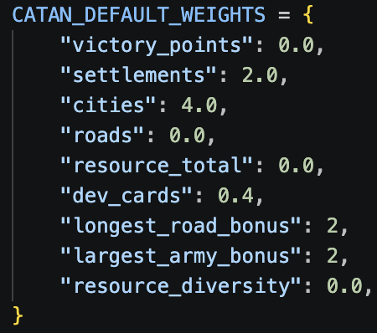
Pictured to the left is a simple example of evaluation weights used to judge the result state of a given rollout.
Our evaluation function takes in these weights, as well as a given game state, and multiplies the quantity of each named feature belonging to the given player at the given state by the weighted value of that feature. These results are then summed to assign that game state one integer value.
The values obtained by the MCTS rollouts massively impact the strategy employed by the agent, as discussed further in the “Results” section. These weights are arbitrarily chosen by Jack and Will. We thought that a Genetic Algorithm might be able to evolve these weights over the course of generations, coming up with a less arbitrary, more optimal set of weights.

Genetic Algorithm
Our evaluation function finds out how much of “x” the player is holding or owns and multiplies the weight by the count of that element. The function will add up the values of the scores from the value of these elements and add them together to create a score.
As for picking the best-performing population genome of weights of a generation, we found the average of victory points that the generation obtained. A higher average of victory points meant a better-performing generation. Even though this use of average victory points may be flawed, we found no better option for evaluating which individuals had the best weights. We’d expect the later generations to be better than the earlier ones (which they were) as the best ones were kept through elitsm and would go on to produce new offspring but whose to say that a population that is split into very good players and very bad ones which coudl result in a lower generation are better than a population that is very good at accumulating a lot of victory points in general.
Many of the weights generated were either close to our default weights or would produce extreme weights. A road weight could go from being valued at 4 to 30, and a settlement weight could go from 4 to 0. Then these weights would be put into a greedy framework and challenge a random agent. The greedy agent would then perform worse than our default weights.
This is a symptom of not being able to allow the individuals to play enough games against each other and not evolve enough over many generations. If this project was done again, I would either get a better computer or use another language than Python to run the game at quicker speeds, allowing for more games to be played.

Data & Experiments
Our project doesn’t rely on any third-party data or dataset; data is generated by agent simulations using the engine detailed in “Method/Game”.
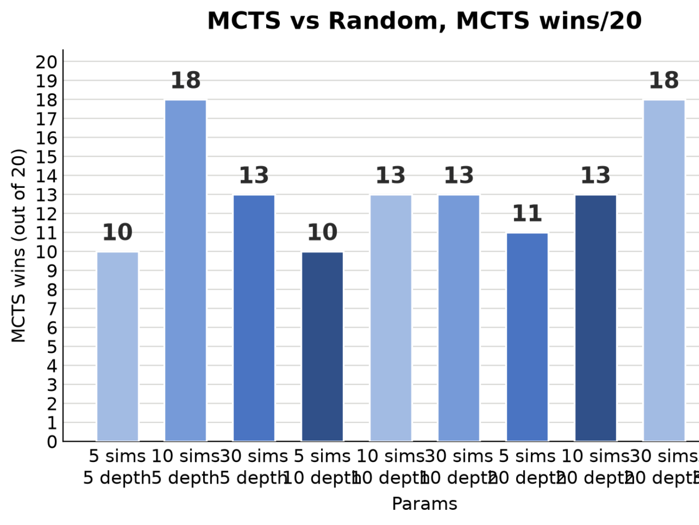
We ran several experiments with each agent in our quest to tune models to the highest capability. Our general test/baseline model was our random agent; if an agent is consistently, conclusively beating the random agent, then we can conclude that the agent’s additional scaffolding is resulting in some advantage.
To test different Monte Carlo Tree Search hyperparameters, we tested different combinations of hyperparameters against the random agent :
In general, we found that simulation count had a greater correlation with win rate than rollout depth. This can be explained by the fact that Catan is a very stochastic game; chance heavily impacts every turn, so simulating deeper into the tree decreases the likelihood of ever reaching that specific game state. An increase in simulation count increases the number of rollouts that happen at a given decision point. At low rollout depth with high simulation count, the model can “see” a realistic level into the future, and simulate that short future enough times to be confident in the quality of the rolled-out states that it sees. That being said, we saw the best performance out of the MCTS with higher simulation counts and higher rollout depth.
This method of testing against the agent helped reveal a number of bugs in the MCTS model. The most severe of which was an undervaluing of winning game states for the player for which the state was terminal. The value returned by winning game states was often much lower than that of other positive states, and this caused the MCTS model to “intentionally” stall out games, playing moves it knew wouldn’t win and allowing the random agent to catch up.
For each of Greedy, MCTS, and GA, we tested various different evaluation functions against each other. The Greedy algorithm, a victim of looking only one game state ahead, struggled to beat the random opponent over half the time with most weight sets. The MCTS model (rollout_depth=30, simulation_count=60) beat the random opponent over four-fifths of the time with most weight sets, and often beat the random opponent 20/20 times.

Results
MCTS Trials
As explained in “Data & Experiments”, our best MCTS models easily beat Random.
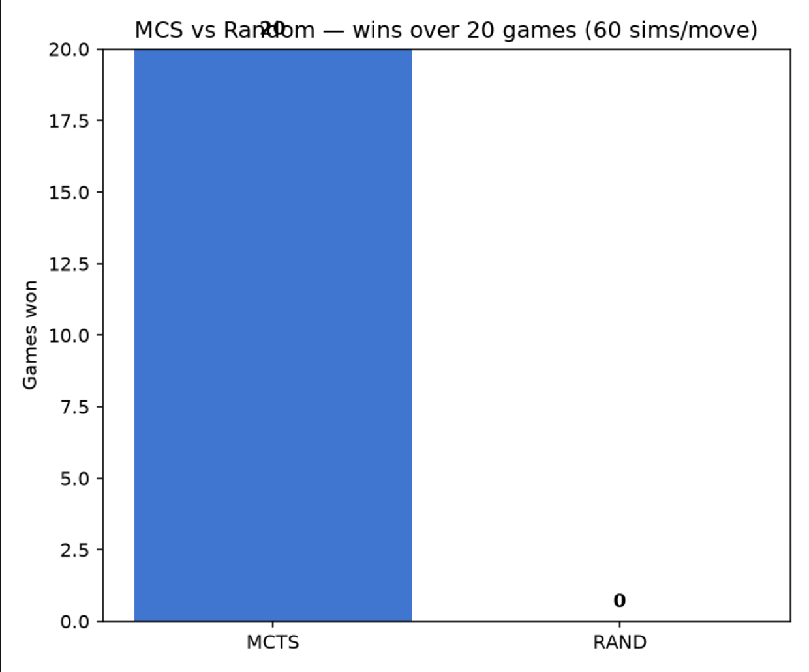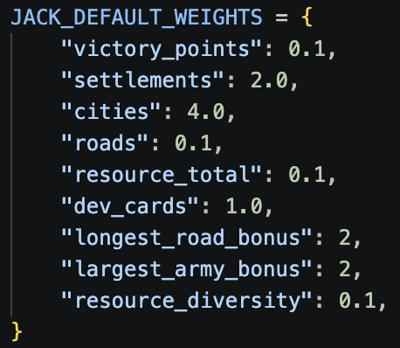
Left: MCTS agent (60/40 sims/depth) vs Random (20-0); Right: MCTS weights used
One of our original project motivations was to test two agents with different Catan philosophies. To do so, two MCTS models were given evaluation weights representing two different archetypes of Catan strategy: City Building (prioritizes building cities over other means of obtaining VP) and Dev Card Chasing (expands, collects, and buys development cards).
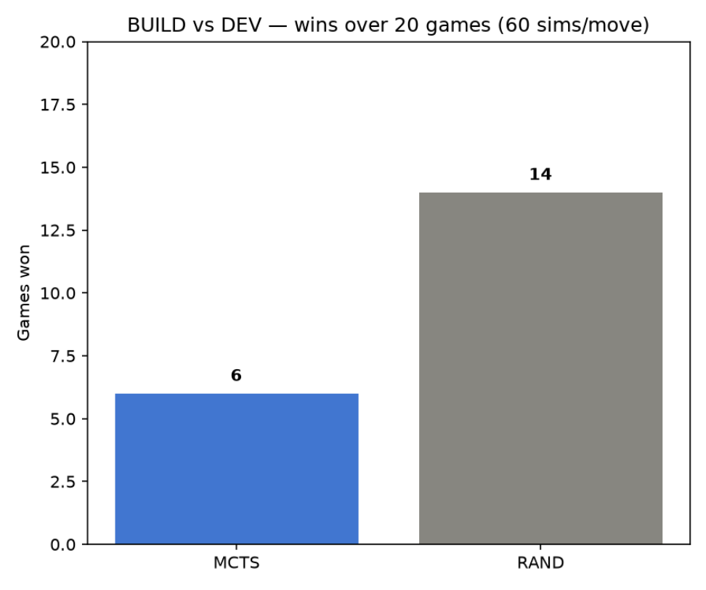
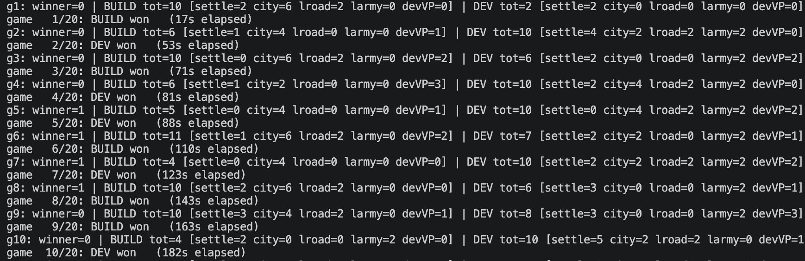
Left: Results of BUILD vs DEV game-by-game, 10 games; Right: Win Count, BUILD vs DEV
Above are the results of 20 games of City Building vs Dev Card Chasing strategies. Notice, in the left image, the different methods of VP accumulation by each agent. City Building Agent builds 4-6 cities each game, rarely wins Longest Road, and rarely wins Largest Army. Dev Card Chasing Agent almost always wins Largest Army and Longest Road, a symptom of spending a higher proportion of resources on Knight and Road Building Dev Cards. To our surprise, the Dev Card Chasing Agent won 14/20 games. Many of the Dev Cards purchased allowed DCCA to expand its territory faster than CBA, as well as inhibit CBA’s progress through the use of Knights and Road Building. This is a fun result, as most players in real life tend toward one of those two baseline strategies, and it was fun to compare agents modeling similar strategies.

Greedy Trials
Greedy vs Random: Random won ~60% of 50 games played
Greedy vs MCTS: MCTS won ~52% of 50 games played (25 simulations and a 5-rollout depth)
MCTS vs Random: MCTS won ~80% of 50 games played (25 simulations and a 5-rollout depth)
MCTS vs Random: MCTS won ~96% of 50 games played (50 simulations and a 40-rollout depth)
Coevolution-Greedy vs Greedy: Greedy won ~54% of 50 games played
Coevolution-MCTS vs Greedy: MCTS won ~74% of 50 games played
We found that MCTS performed generally well against the other agent, especially when the simulation count was high. Rollout depth was not that impactful, as the further you go down the game tree in rollout and less likely you are to actually hit that same line of events in a real game. So looking down the tree with a high branching factor is not that important as the number of simulations you run. The MCTS agent only had to look a little down the game tree to outclass the other agents. Coevolution on MCTS weights also seemed to improve the MCTS agent with more fitting weights. But the same was not true for using coevolution of the greedy agent. If anything, the weights found by a coevolution run seemed to make the greedy agent typically perform the same, if not worse. We believe this is because of our lack of computational power to make a large population and simulate a lot of games. For example, the largest we got with population size was 16 individuals, 10 generations, and 4 games per individual per generation. This took a couple of hours to run. So it was hard for us to do the coevolution agent the justice we intended to give it.

Link to GitHub Repo

https://github.com/wbartlik2004/CatanAgent

Team Contribution Statement

Jack came up with most of the framework for how the game state worked, but both of us contributed to the game state, rules, and anything else related to simulating the game. Jack made the random bot and MCTS agent. Will made the greedy agent, the coevolution agent, and the evaluation function. Overall, we both did around the same work for the presentation and testing.

References

